*Florida International University*

*School of Computing and Information Sciences*

Software Engineering Focus

Feature Document

User Story ID #675 Robot Controller

**Name: Daniel Rivero**

**Team Member(s):** Pachev Joseph, Hamilton Chevez, Bernardo Pla, Daniel Khawand

**Project: WebVR 1.0**

**Product Owner(s)**:

**Mentor(s)**: Francisco Ortega

**Instructor**: Masoud Sadjadi

**User Story Name: Robot Controller**

* Description: As a developer who programs this game, I want the controller for the robot to be the interface between what the user does when programming the robot with the actions provided to the robot by the back-end.

Acceptance Criteria

* Controller should be programmed using the MonoBehavior interface from unity.
* Controller should be able to interface between front-end assets to the state machine.ma

**Use Case**

* Name: moveForward
* Actor: Robot, System
* Preconditions: A module with the name ‘moveForward’ has been placed in the programming board.
* Description:
* Robot detects the moveForward module placed on the programming board
* Robot sends moveForward module information to the system
* System generates state machine based on this module
* System sends generated state machine to robot
* Robot changes internal state from ready to running
* Robot executes the moveForward state from the state machine
* Robot moves forward
* Robot changes internal state from running to terminated
* Robot executes next state (EXCEPTION: noMoreStates)
* EXCEPTIONS
* noMoreStates : robot will not transition into another state if there is only one state or

no more states in the state machine.

**Use Case Diagram**

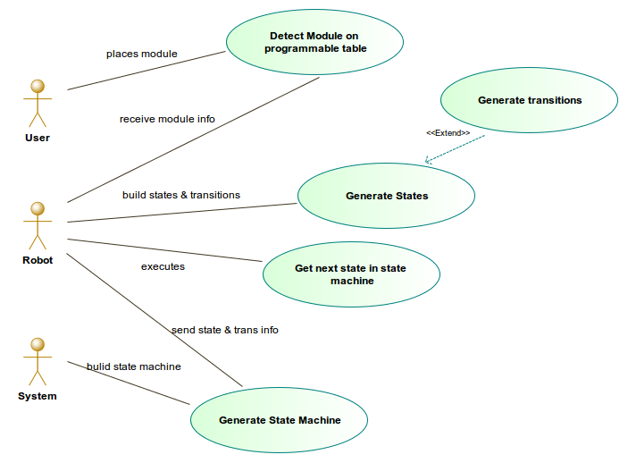

**Sequence Diagram**

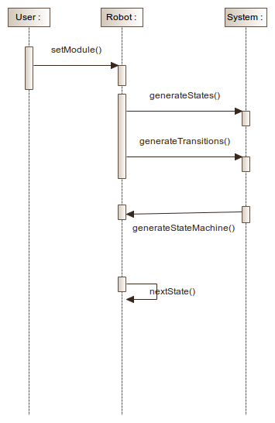

**Class Diagram**

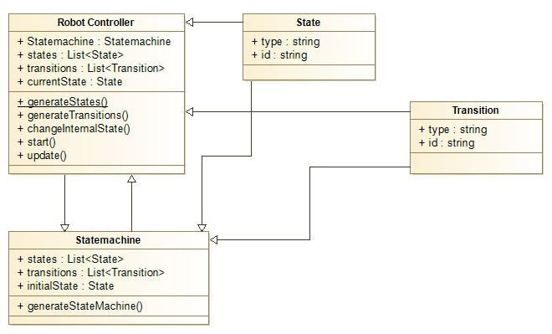

**Unit Test**

* Test case ID:
* Description/Summary of Test:
* Pre-condition:
* Expected Results:
* Actual Result:
* Status (Fail/Pass):

**Integration Test**

**Visual User Guide** <like one or two screenshots of the feature. For the hardware project, a photo of device is required>